**LAB ASSIGNMENT – 2**

**NAME : PRATHAPANI SATWIKA**

**REG.NO. : 20BCD7160**

**Q6.Given a two list. Create a third list by picking an odd-index element from the first list and even index elements from second.**

**For Example:**

**listOne = [3, 6, 9, 12, 15, 18, 21] listTwo = [4, 8, 12, 16, 20, 24, 28] Expected Output:**

**Element at odd-index positions from list one [6, 12, 18]**

**Element at even-index positions from list two [4, 12, 20, 28]**

**Printing Final third list [6, 12, 18, 4, 12, 20, 28]**

**CODE :**

listOne = [3, 6, 9, 12, 15, 18, 21] listTwo = [4, 8, 12, 16, 20, 24, 28] listThree = list()

oddElements = listOne[1::2] print("Element at odd-index positions from list one") print(oddElements)

EvenElement = listTwo[0::2] print("Element at even-index positions from list two") print(EvenElement)

print("Final third list") listThree.extend(oddElements) listThree.extend(EvenElement) print(listThree)

**OUTPUT :**

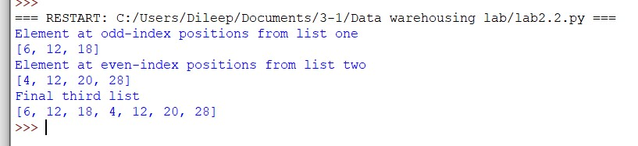

**Q7.Given a two list of equal size create a set such that it shows the element from both lists in the pair Expected Output:**

**First List [2, 3, 4, 5, 6, 7, 8]**

**Second List [4, 9, 16, 25, 36, 49, 64]**

**Result is {(6, 36), (8, 64), (4, 16), (5, 25), (3, 9), (7, 49), (2, 4)}**

**CODE :**

first_list = [2, 3, 4, 5, 6, 7, 8] print("First List ", first_list)

second_list = [4, 9, 16, 25, 36, 49, 64] print("Second List ", second_list)

result = zip(first_list, second_list) result_set = set(result) print('Result is',result_set)

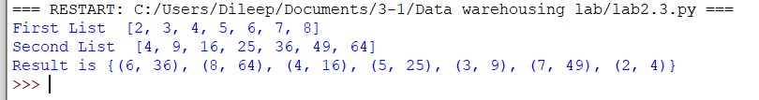

**Q8.Given a dictionary get all values from the dictionary and add it in a list but don’t add duplicates.**

**speed ={'jan':47, 'feb':52, 'march':47, 'April':44, 'May':52, 'June':53, 'july':54, 'Aug':44, 'Sept':54} Expected Outcome: [47, 52, 44, 53, 54]**

**CODE :**

speed = {'jan': 47, 'feb': 52, 'march': 47, 'April': 44, 'May': 52, 'June': 53, 'july': 54, 'Aug': 44, 'Sept': 54}

print("Dictionary's values - ", speed.values())

speed_list = list()

# iterate dict values for val in speed.values():

# check if value not present in a list if val not in speed_list: speed_list.append(val) print("unique list", speed_list)

**OUTPUT :**

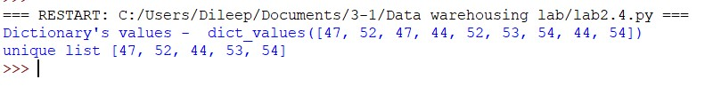

**Q9. Remove duplicate from a list and create a tuple and find the minimum and maximum number. For Example:**

**sampleList = [87, 45, 41, 65, 94, 41, 99, 94] Expected Outcome:**

**unique items [87, 45, 41, 65, 99] tuple (87, 45, 41, 65, 99) min: 41 max: 99 CODE :**

sample_list = [87, 45, 41, 65, 94, 41, 99, 94]

print("Original list", sample_list)

sample_list = list(set(sample_list)) print("unique list", sample_list)

t = tuple(sample_list) print("tuple ", t)

print("Minimum number is: ", min(t)) print("Maximum number is: ", max(t)) **OUTPUT :**

